VIP Virtualization Infrastructure

[page 1]

(Company logo)

(Microsoft Certified Partner icon)

(suggested images - montage of diverse employees on laptop, desktop, tablet, smart phone, etc.)

(headline)

VIP Virtualization Infrastructure Process

(subhead)

A united approach to data - and to business

(copy)

Successful businesses fully integrate their operations, as opposed to working with a “silo” mentality. It makes sense - good business sense - for departments to collaborate with each other. Human resources, IT, finance, marketing, legal… they all require effective, two-way communication for optimal efficiency.

The same holds true for the IT department itself. Are your IT network, server and storage teams separate or interconnected? Are tasks, workflows and steps isolated or streamlined?

Is your data center a single entity, or is it a piecemeal operation? There’s a reason it’s called a data CENTER. Just as the staffers in your departments need to talk with one another, your data needs to be accessible to employees across all divisions, wherever they are, whenever they need it.

With telecommuting, off-site business meetings and satellite offices, data integration is more important than ever. With [COMPANY]’s Virtualization Infrastructure Process (VIP) featuring Virtual Desktop Integration (VDI), your business can position itself for real efficiencies - and real savings.

At [COMPANY], our strength is our versatility. We can work with any enterprise-level data center technology. We focus on your data needs - from storage to networking to security - so that you can focus on running your business.

(suggested graphic)

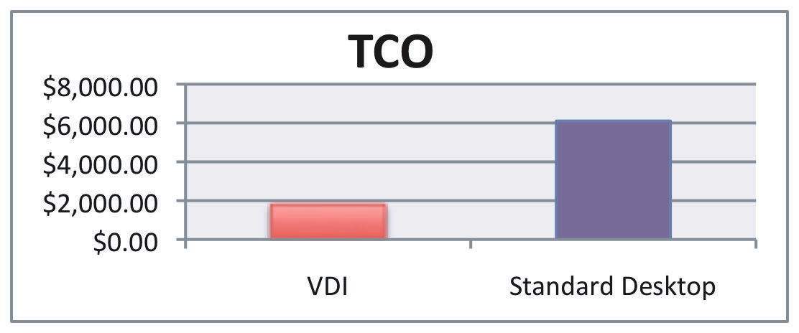
3-Year Total Cost of Ownership Comparison 1000 Task Worker Desktops*
* Comparison based on 1000 desktop deployment, using 3rd party calculator.
[page 2]
(suggested image - available for nominal fee at
http://www.dreamstime.com/royalty-free-stock-image-internet-business-integration-on-different-platfor-image4366486)
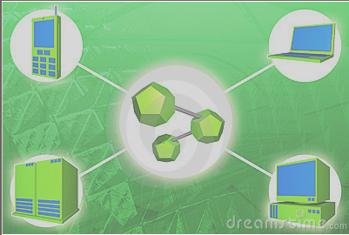

Why VIP? Why not?

When it comes to the bottom line, it’s easy to justify the initial capital outlay for the Virtualization Infrastructure Process. Here are just a few of the many benefits a Virtual Desktop Integration (VDI) solution provides over traditional PC environments:
- Lower management costs
- Increased performance and end-user impact
- Improved scalability
- Enhanced features and functionality
- Increased productivity

While the benefits of infrastructure virtualization are real, businesses often face challenges in making the changeover. According to a Forrester survey, these include getting executive buy-in, motivating application owners to move to virtual machines, and restructuring teams for maximum efficiency in a virtualized environment. [COMPANY] can help you sell VIP to your company VIPs. We’re ready to answer your questions, help you overcome any roadblocks, and make your infrastructure virtualization a reality.

Why [COMPANY]? Experience counts.

With over 25 years of experience delivering enterprise solutions, we understand your data access and security needs. Our VIP is designed and integrated with your current environment, regardless of vendor. We specialize in:
- Asset configuration & management - Microsoft SCCM, Tivoli, HP, Dell
- Collaboration through current technology stack, Cisco UC, Microsoft Exchange, Shoretel (VOIP), SharePoint
- Directory design migration & management
- Storage optimization - design and management of enterprise storage
- Data tiering
- Thin provisioning

We’re with you every step of the way. First, we assess your company’s current and future business needs so that we can develop a custom plan to your specifications. Next, we turn that plan into a program design, then deploy and migrate your program. [COMPANY]’s involvement doesn’t end there. We help you manage the program and provide technical support as needed.
For pricing, references and more information, visit us online at [URL] or contact us at (000) 000-0000 or [email].

